LABORATORIO ARTIGIANO RETI
di ARCHETTI CARLO
Reti da Pesca – Sport – Caccia
Recinzione Impianti Sportivi
Antinfortunistica – Acquacoltura
25058 SULZANO (BS) – Via Tassano, n. 8
Tel. e Fax 030/985290 – Tel. Ab. 030/985191
Cell. 328 0562071 c.f. RCHCRL64C01F532U – P.I. 03216410179
www.retiarchetti.it – info@retiarchetti.it
www.retiarchetti.com – info@retiarchetti.com
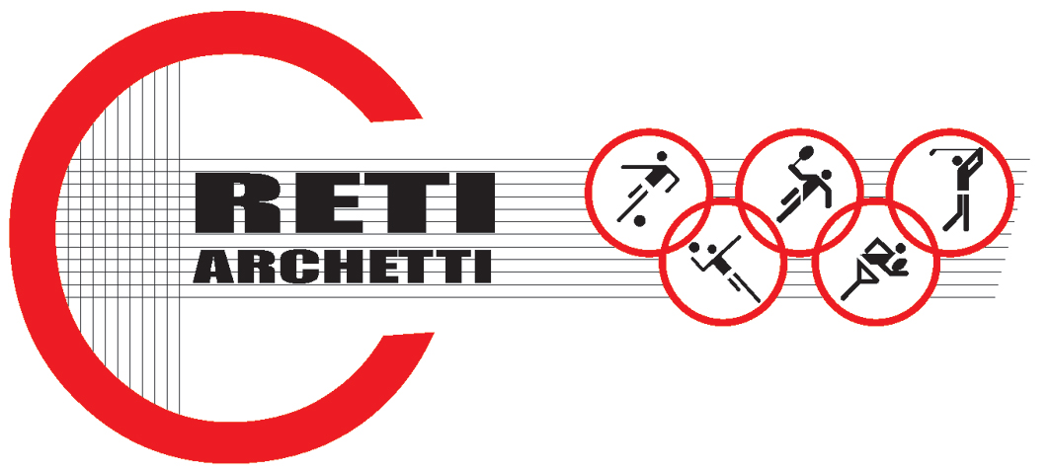

TECHNICAL DATA SHEET ART.CODE: AN 4

NET MADE OF HIGH RESISTANT NYLON, MESH mm 25 x 25 AND THICKNESS mm 2,5

NET WITH SQUARED MESH

YARN THICKNESS: 210/96 - Ø 2,5 mm

MESH mm 25

UNMOVABLE STRANDED KNOT

MATERIAL: MULTIPLE YARNS

MATERIAL COMPOSITION: NYLON POLYAMIDE

COLOR: WHITE

HUMIDITY ABSORPTION: 30%

MATERIAL CAN BE EXPOSED TO THE FOLLOWING TEMPERATURE – 10 + 20. GUARANTEE: 3 YEARS

SLOW COMBUSTION

STABLE PRODUCT

MANUFACTURED AT CONTINUOUS EXTRUSION

ULTIMATE STRENGTH (TO PULL A MESH FROM ONE END TO THE OTHER): KG. 92

